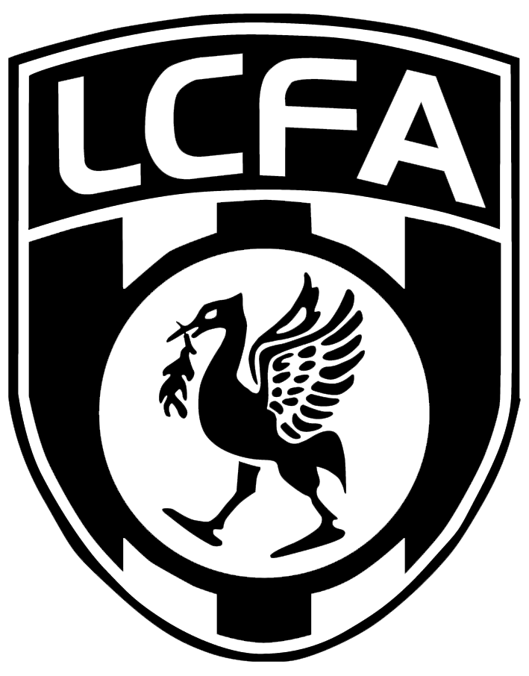
Liverpool FA
County Cup Competitions 2023-2024

COMPETITION: |  |  |  |  |  |  |  |  |  |  |  | (please inc age group)
Date: |  |  |  |  | Venue:
Home club: |  |  |  |  |  |  |  |  |  |  | Goals:
Away club: |  |  |  |  |  |  |  |  |  |  | Goals:
Match Results must be reported by the HOME TEAM by replying to the Fulltime system text message and to competitions@liverpoolfa.com within 24 hours of the match being completed.
2. Match Results must be reported by the HOME TEAM by replying to the Fulltime system text message and to competitions@liverpoolfa.com within 24hours of the match being completed. |  | Players Name |  |  |  | Goals Scored |  |  |  |  | Cautioned/  Sent off
1
2
3
4
5
6
7
8
9
10
11
Subs Used
12
13
14
15
16
*NOTE: No Extra Time is played in any LCFA Competition!
If the score was determined by the taking of penalty kicks, please indicate below:
PENS: |  |  |  | Home (scored) |  |  |  |  | Away  (scored)
Referee (name): |  |  |  |  |  | Referee Marks: /100
Signature:

100 to 86 – Excellent /85 to 76 – Very Good/75 to 61
Satisfactory/60 and below – Serious Development Needed
(if score is less than 60 a report must be submitted to competitions@liverpoolfa.com)
Name: |  |  |  |  |  | Position held in Club:
Please forward all completed team-sheets via email (competitions@liverpoolfa.com)
within 7 days of the match. (Failure to do so may result in a fine)

Liverpool FA
County Cup Competitions 2023-2024

Please return completed team sheets to:
competitions@liverpoolfa.com

Referees Fees:

Fees are to be equally split between both teams

 | Saturday Challenge & Sunday Premier Cups | Saturday/ Sunday Junior & Intermediate Cups | Saturday/Sunday Youth (U18) Cups | Saturday/Sunday U13 & U16 Boys Cups
Referee | £50.00 | £50.00 | £35.00 | £30.00
Assistants (if applicable) | £35.00 | £50.00 | £35.00 | £30.00

 | Women’s Challenge Cup | U14 & U16  Girl’s Cups
Referee | £40.00 | £30.00
Assistants  (if applicable) | £30.00 | £30.00

