Royal Navy Football
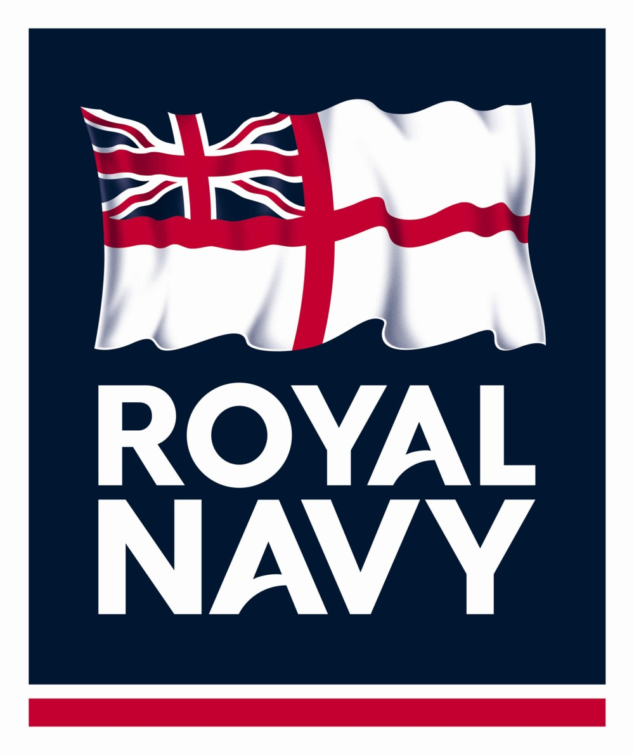

Association

Representative Coaches Application Form

Section 1:- Personal details

Position : Seniors Women

Development Head Coach Under 23’s Under 21’s

Christian Name: ................................. Surname: ……….......................................
Rank/Rate: ................................... Service No: …….................................
D.O.B: ..........................................
Civilian Address: ....................................................................................................
……………………………………………..Post Code: ...................................... .
Home tel: .................................................... Work tel: ............................................
Mobile: .........................................
E-mail: (Service)......................................................................................................
E-mail: (Civilian).....................................................................................................
Current Appointment /Assignment: ……………………………………………….
Estimated Duration of Appointment / Assignment:………………………………..
Future Appointment / Assignment::…………………………………………………
……………………………………………………………………………………

Section 2:- Coaching Details:

Actively Coaching Yes / No Club/Organisation................................................

Member RNFA Coaches Ass.
Member FA Coaching Licensing Scheme
FAN Number ………………………………………………………………………
- Relevant Football Qualifications: ……………………………………………………………………………………………………………………………………………………………………………………………………………………………………………………………………………………………………………………………………………………
- Coaching Résumé: ……………………………………………………………………………………………………………………………………………………………………………………………………………………………………………………………………………………………………………………………………………………………………………………………………………………………………………………………………………………………………………………………………………………………………………………………………………………
Completed form can either be sent directly by e-mail to Secretary@navyfa.com or posted to:
The Secretary
RNFA
HMS TEMERAIRE
Burnaby Road
Portsmouth, PO1 2HB

