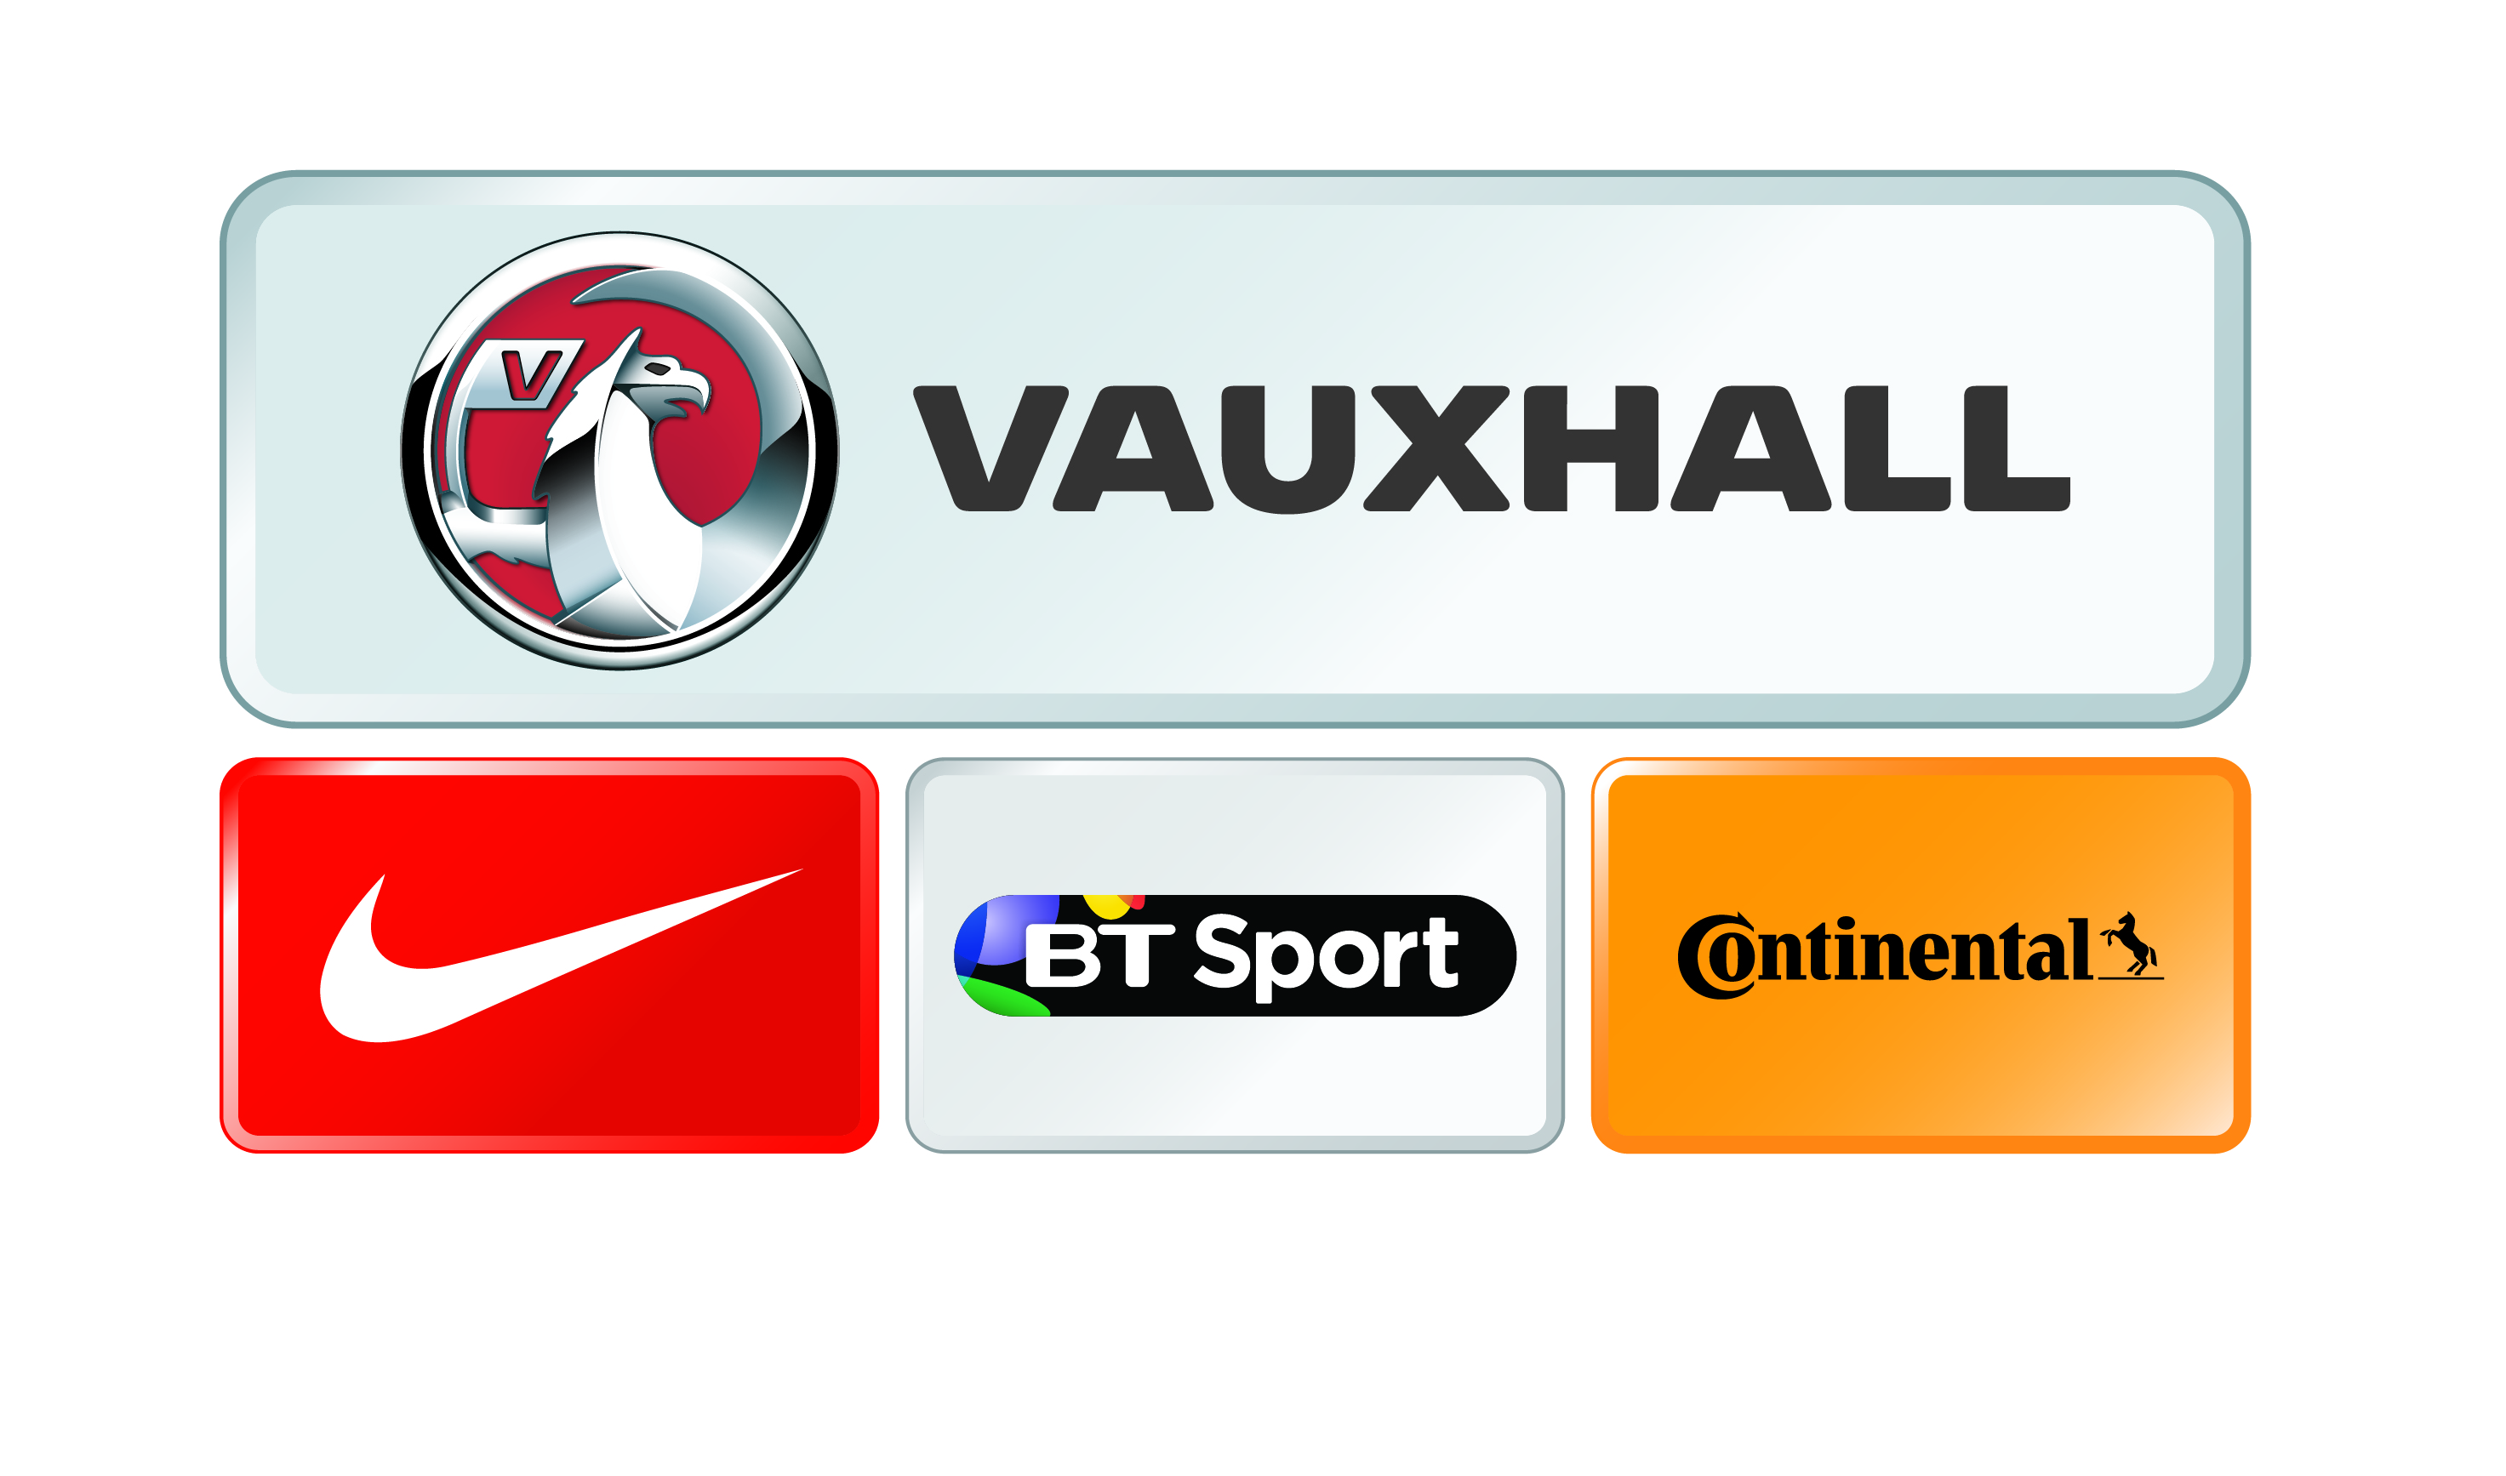
SEE ENGLAND IN ACTION

Women’s International Friendly
ENGLAND v USA
STADIUMMK
Friday 13 February, Kick-off 8.00pm

GROUP BOOKING FORM

Closing date for applications is 2pm on Monday 9 February, subject to availability
Minimum 15 tickets per application
£3.00 Adults & £2.00 Concessions (Children under 18, OAP’s over 65, Students with a valid NUS card)

Once completed, please email this form to England@mkdons.com or post to Box Office, StadiumMK, Stadium Way West, Milton Keynes, MK1 1ST

If you require parking for your group, you will need to book in advance. Please note-Mini bus and coach spaces are allocated on a first come first served basis. Please confirm how many spaces you require by emailing England@mkdons.com

Please note - All tickets will be posted to the address supplied. Please be aware that the credit card must be registered to the address given. For any cheque payments – please make payable to’ Milton Keynes Dons Limited’
CONTACT NAME
POSTAL ADDRESS FOR TICKETS
TELEPHONE: DAY / EVE
EMAIL ADDRESS

 | TOTAL TICKETS | AMOUNT £
ADULT @ 3.00 PER TICKET |  | £
CHILDREN (UNDER 18’s), OAP’s (OVER 65’s), STUDENTS WITH A VALID NUS CARD @ £2.00 PER TICKET |  | £
BOOKING FEES & ADMIN CHARGES - £3.00 PER ORDER | 1 ORDER | £ 3.00
TOTAL TICKETS & COSTS DUE |  | £
PAYMENT BY CREDIT/DEBITCARD
NAME ON CARD
CARD NO.
ISSUE NO.
VALID FROM |  |  |  |  | UNTIL
SECURITY NUMBER (LAST 3 DIGITS ON BACK OF CARD)

NOTE  There should be at least one adult per ten children in the group.  Please claim only for the number of tickets you can guarantee will be used. If you have any tickets left over please return to the ticket office immediately. |  |  | TERMS AND CONDITIONS  Applications are subject to availability at the time of booking.  I accept these terms and conditions as stated above:  Print name
 | Please tick here if you wish to receive further information from The FA |  | Signature
NOTE: All children must be carefully supervised by an adult while on the Club premises

